Customer Support Center Upgrade
Network Infrastructure
DeShaun Riddick

DeVry University

NETW585

Professor James Karagiannes

11/30/2025

Project Scope
Project Title: Customer support center network infrastructure replacement and modernization
Client: Medium sized locally owned and operated cable company
Date: 11-30-2025
Version: 1.1
Prepared By: DeShaun Riddick
Contents
Project Scope 2
Project Goal 5
Design Requirements 6
Network Documentation 7
NEI ), Customer Support Center 14
References: 14

Project Overview
The Nuvizzion Entertainment Inc. (NEI), customer support center, services in Long Island, New York. NEI employs 50 to 150 employees with about 40 field technicians. NEI is in desperate need of an overhaul of the antiquated network that operates inefficiently. NEI uses CRM to log account interactions pertaining to TV, Phone, internet and billing issues. Coordination with the 40 field technicians rolling out to service, install or promote new services onsite for new customers the CRM is used, but has software issues as it is legacy software.
What the goal of this project aims to accomplish deals with design, implementation and validation of a modern, secure, and scalable network infrastructure for:
- Upgrade network infrastructure
- Support Long Island footprint for our network more efficiently
- Enable and streamline communication technologies between field techs and the call center
- Protect business data and continuity
The NEI Information Technology Department are skilled professional; has a consultant-led solution using project management and networking methodologies, with two paramount milestones from the Stakeholders at NEI:
- Design a scalable and reliable network architecture that promotes allocative efficiency, minimal downtime, future growth
- Administer a robust network security measure that protects the customer data and system integrity
Project Objectives
Objective | Description | Alignment with Stakeholders
Modernize Infrastructure | Replace legacy routers, switches, firewalls, and wireless access points with modern high-performance equipment. | Scalability / Reliability
Support Fixed & Mobile Users | Provide stable high bandwidth connectivity for 150 office staff and secure remote access for field technicians. | Scalability / Reliability  Implement Robust Network Security Measures
Segment Network | Utilize VLANs to isolate traffic. | Scalability / Reliability  Implement Robust Network Security Measures
Ensure Redundancy | Deploy redundant Internet connections, and critical devices to eliminate single points of failure. | Scalability / Reliability
Enhance Security | Deploy firewall, VPN for mobile access, encryption, access controls, and intrusion detection to protect sensitive customer data. | Implement Robust Network Security Measures
Scalability | Designed for future expansion, utilize load balancers. | Scalability / Reliability
Compliance & Documentation | Ensure compliance with data protection standards and provide full network documentation. | Implement Robust Network Security Measures
Enable Tiered Support Workflow | Integrate networks with existing ticketing systems to streamline communication between Tier 1 and Tier 2 staff and field technicians. | Scalability / Reliability

Activities
Conducting a network assessment to detail an analysis of the existing antiquated network infrastructure. This includes current performance, bottlenecks, security vulnerabilities, and application dependency. Finding out where the low hanging fruit is and what challenges NEI currently faces will provide a well-lit road map for a makeover.
- Collecting a comprehensive list: From Stakeholders of NEI, IT, Customer Support, Field Operations and Management of what is functional and what are nonfunctional requirements.
- Network Design:
- Core LAN/ WAN Design: Develop a high-level detailed network architecture, topology, IP addressing routing protocols and wide area network connectivity Internet service provider integration.
- Wireless network Design: Plan for the design of secure high performance Wi-Fi coverage for the NEI support center, including guest access if required.
- Mobile User Connectivity: Design and implement secure Virtual Private Network (VPN) solutions and remote access policies for the 40 technicians, ensuring reliable and secure access to the internal resources over A 50-mile service area.
- Security Architecture Design: Integration of firewalls, IDs/ IPS, VPN Concentrators, NAC, and security policies as to implementing A robust network with security measures.
- Testing & Validation: comprehensive testing of network functionality, performance, and security including user acceptance testing. Version Control of the CRM upgrade.
- Documentation: Creation of network diagrams, security policies, operational procedures, and troubleshooting guides.

Project Goal
In the increasingly complex market environment of service products, traditional single-skill call centers are gradually being replaced by multi-skill call centers. Multi-skill call centers are typical Parallel-Server Systems (Shibboleth Authentication Request, n.d.).
Some of the minimum Gbps wired speeds for all staff are a functional requirement. NEI employs 150 office workers providing the correct network design that must be affordable, manageable, and reliably secure. The infrastructure should be able to scale to support 200 users within the next two years. Performance matters and it is not wise to take shortcuts to save on cost.
In week 1 there will be a stakeholder kick off for the sign off & on project charter. Week 2 will go into the planning for the scalability of the network with work breakdown structures in week 3 we'll move to the design phase to develop the physical and logical diagrams to ensure the security of this architectural design with client approval. This is the primary focus that is critical. Week 5 the hardware procurement will be initiated after the installation configuration should be discussed along with the integration of pre-existing systems if possible. Week 8 performance and security with a failover testing will be paramount.
In this stage, testing and validation will provide feedback on how the network configuration affects staff and field technicians. In week 9 The IT staff can commence training the field technicians on use of the virtual private network so they could be properly onboarded. In the final week 10 looking at the lessons learned/ after action and handing over documentation the project can be signed off. It's important to identify the risk and leave room for downtime and repair updates. Any changes to the formal process for the scope will require a client's approval as we will communicate weekly status meetings with the stakeholders.

Design Requirements
Current Design:
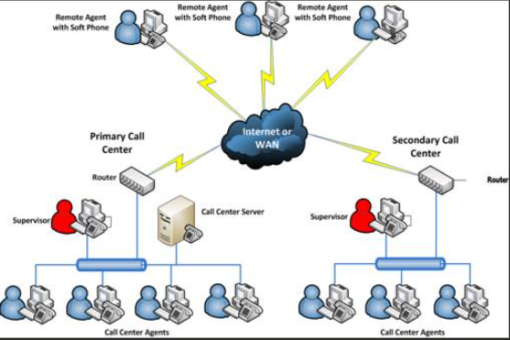
(An In-Depth Guide to Writing Network Documentation | NetBox Labs, n.d.)

Network Documentation
Organization: Nuvizzion Entertainment Inc.
Location: 25 Melville Corporate Drive Long Island, New York
Capacity: 50 to 150 Call Center Agents + 40 Field Technicians
Document Version: 1.8
Last Updated: January 28, 2008
- Physical Layout
  - Floor Maps
Floor 1: Main call center floor (100 agents), Network operations Center (NOC)
Floor 2: Secondary call center (20 agents), Training rooms, Break areas
Floor 3: Management offices, IT Department, Server Room
Detailed Device Locations
Floor 1 – Main operations
Grid Reference System: A1- J20
- A1 – A5: IDF – 1 (Intermediate Distribution Frame)
- B1 – H15: Agent workstations (Rows 1-10)
- I1 – I5: Supervisor stations
- J1 – J3: NOC monitoring stations
- J15 – J20: MDF (Main Distribution Frame)
Server Room (Floor 3)
- Rack A1 – A4: Core network equipment
- Rack B1 – B3: VoIP/PBX systems
- Rack C1 – C2: Storage arrays
- Rack D1 – D3: Application servers
1.2 Rack Diagrams
Rack A1 – Core Network
U42 - 44: Cisco Nexus 9504 Core Switch #1
U39 - 41: Cisco Nexus 9504 Core Switch #2
U37 – 38: Palo Alto PA-5260 Firewall (Primary)
U35 – 36: Palo Alto PA-5260 Firewall (Secondary)
U33 – 34: F5 BIG- IP Load Balancer
U30 – 32: Cable management
U25 – 29: Cisco ISR 4451 Edge Routers (x2)
U20 – 24: Patch panels (Copper)
U15 – 19: UPS Battery Backup
U10 – 14: Cisco Catalyst 3850 Distribution Switches
U5 - 9: Patch panel (Copper)
U1 – 4: PDU Units
1.3 Cabling Infrastructure
Cable Types and Specifications
- Backbone: Single-mode fiber (OS2) - 10 Gbps between floors
- Horizontal: Cat6a UTP - Supporting 1Gbps to workstations
- Data Center CAT7 STP - 10Gbps server connections
- VoIP: CAT6 UTP - Dedicated voice VLAN cabling
Color Coding Scheme
- Blue: Standard data connections
- Yellow: VoIP/telephony
- Red: Security/surveillance systems
- Green: Guest/visitor network
- Orange: Cross-connects/uplinks (Aleksic, 2025)
- Purple: Management network
- Logical Layout
  - Network Diagram
High-Level Topology
Internet (Dual ISP)
Primary : AT&T 2Gbps Fiber
Secondary : Lightpath 1Gbps Backup

[ Firewall Cluster ]

[ Core Switch ]
Server VLAN (10.1.0.0/16)
Voice VLAN (10.2.0.0/16
Data VLAN (10.3.0.0/16
Management VLAN (10.4.0.0/24)
Guest VLAN (172.16.0.0/24)

2.2 IP Addressing Scheme
VLAN Configuration
VLAN ID | NAME | SUBNET | GATEWAY | DHCP RANGE | PURPOSE
10 | Servers | 10.1.0.0/16 | 10.1.0.1 | Static Only | Server Infrastructure
20 | Voice | 10.2.0.0/ 16 | 10.2.0.1 | 10.2.1.1-  10.2.10.254 | VoIP phones
30 | Data | 10.3.0.0/ 16 | 10.3.0.1 | 10.3.1.1-  10.3.20.254 | Workstations
40 | MGMT | 10.4.0.0/ 24 | 10.4.0.1 | Static Only | Network Management
50 | Wireless | 10.5.0.0/ 16 | 10.5.0.1 | 10.5.1.1-  10.5.50.254 | Wi-Fi Clients
60 | Field_VPN | 10.6.0.0/ 24 | 10.6.0.1 | 10.6.0.10-  10.6.0.100 | Field Technician VPN
100 | Guest | 172.16.0.0/ 24 | 172.16.0.1 | 172.16.0.100-200 | Guest Network
2.3 IP Address Management (IPAM)
Tool: Infoblox DDI (DNS, DHCP, IPAM) (Infoblox, 2025)
- Primary Server: 10.1.10.10
- Secondary Server: 10.1.10.11
IP Allocation Registry
Critical Infrastructure:
10.1.1.1 | Core Switch 1
10.1.1.2 | Core Switch 2
10.1.2.1 | Firewall Primary
10.1.2.2 | Firewall Secondary
10.1.3.1-10 | VoIP PBX Cluster
10.1.4.1-5 | Application Servers
10.1.5.1-3 | Database Servers
10.1.6.1-2 | File Servers
10.1.7.1 | Call Recording Server
10.1.8.1-2 | CRM Servers
2.4 Protocols & Services
Routing Protocols
- OSPF Area 0: Core and distribution layer
- EIGRP: Legacy systems integration
- BGP: ISP Connectivity (AS 65001)
Key Services
- QOS: Voice traffic prioritization (DSCP EF 46)
- Multicast: PIM-SM for training broadcast
- STP: Rapid-PVST+ for loop prevention (“Cisco Nexus 5000 Series Switch CLI Software Configuration Guide,” 184444)
- HSRP: Gateway redundancy (Priority 110/100) (Andrea, n.d.)

3. DEVICE DETAILS
3.1 Network Equipment Inventory
Device Type | Model | Serial # | Location | IP Address | Warranty Expiration
Course Switch | Cisco Nexus 9504 | FDO23456789 | Rack A1 | 10.1.1.1 | 2026-06-15
Core Switch | Cisco Nexus 9504 | FDO23456790 | Rack A1 | 10.1.1.2 | 2026-06-15
Firewall | Palo Alto PA-5260 | 012345678901 | Rack A1 | 10.1.2.1 | 2026-12-10
VoIP PBX | Avaya Aura CM | AVA987654 | Rack B1 | 10.1.3.1 | 2025-08-30
Load Balancer | F5 BIG-IP i7800 | F5-ABCD-1234 | Rack A1 | 10.1.2.5 | 2026-03-15
(J, 2025)
3.2 Configuration Backup Schedule
Backup Schedule:
- Daily: Incremental configs @ 02:00 EST
- Weekly: Full configs @ Sunday 00:00 EST
- Location:\backup-SRV\netconfigs\
- Retention: 90 days rolling
- Tool: SolarWinds NCM
3.3 Firmware/ Software Versions
Device category | Current Version | Latest Available | Update Schedule
Core Switches | NX-OS 9.3(8) | NX-OS 9.3(10) | Q2 2024
Firewalls | PAN-OS 10.2.3 | PAN-OS 10.2.4 | Q1 2024
Access Switches | IOS 16.12.5 | IOS 16.12.6 | Q2 2024
Wireless Controllers | 8.10.162.0 | 8.10.171.0 | Q1 2024
(Cisco Nexus 9000 Series NX-OS Release Notes, Release 9.3(8), 2024)
(PAN-OS 10.2.4 Known Issues, n.d.)
3.4 Data Center Infrastructure Management (DCIM)
Tool: Schneider Electric StruxureWare
- Monitoring Dashboard:
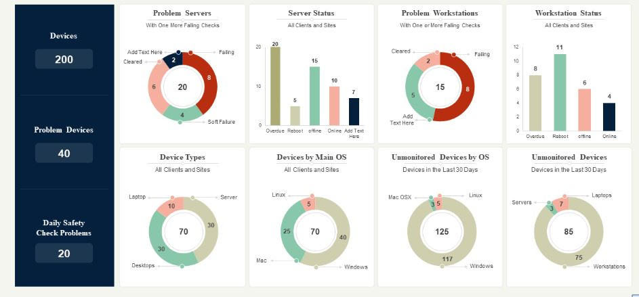
(Comment, n.d.)
- Power Usage Effectiveness (PUE): 1.4 (Kirvan et al., 2025)
- Average Rack Temperature: 68°F ( 20°C )
- Cooling capacity: 150 tons (3 x 50-ton CRAC units) (Chube, 2011)
- UPS runtime: 45 minutes at 80% load
4. Network Topology
4.1 Hierarchical Network Design
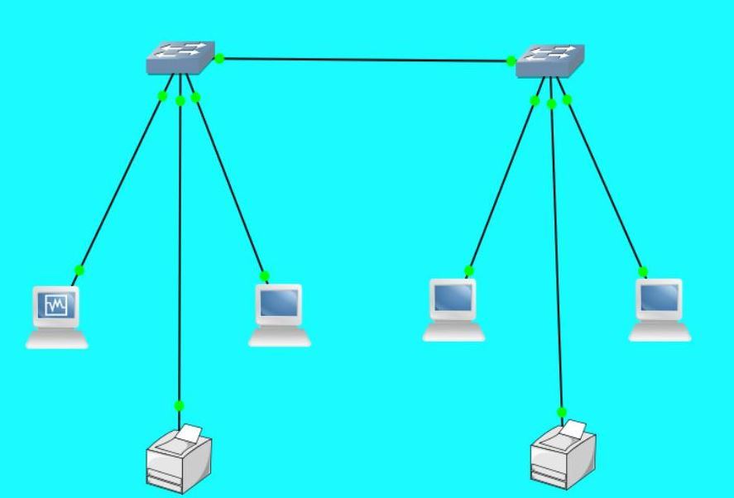
(GeeksforGeeks, 2025)
Core Layer
- Dual Nexus 9504 switches (VSS configuration)
- 40Gbps uplinks to core
- Connected to all distribution switches
Distribution Layer
- 6x Cisco catalyst 3850 (Stack Configuration)
- 10Gbps uplinks to core
- Servers access layer switches per floor
Access Layer
- 24x Cisco catalyst 2960X (48-port)
- 1Gbps uplinks (dual, LAG)
- PoE+ for VoIP phones
4.2 Redundancy Architecture
Internet Connectivity
Primary ISP (AT&T)
Secondary ISP (Comcast) [Active/Standby Firewalls] Core
Critical System Redundancy
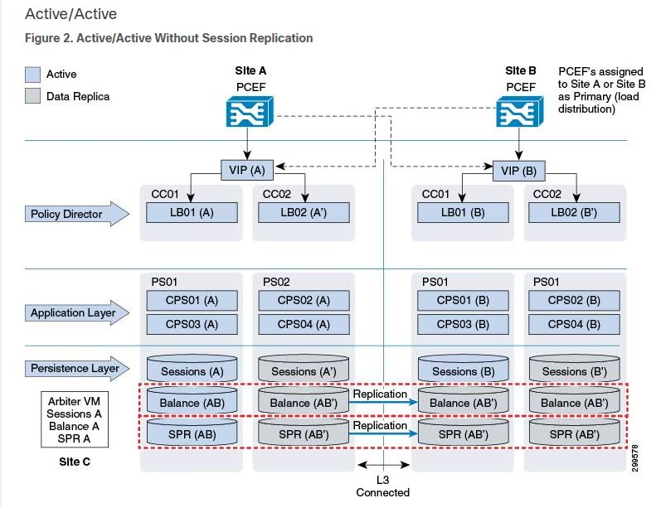
(CPS Geographic Redundancy Guide, Release 24.2.0 - GR Reference Models [Cisco Policy Suite for Mobile], 2024)
- VoIP System: active/ active with session replication
- Database: primary/ secondary with real- time replication
- File Storage: RAID 6 with hot spare, replicated to DR site (Synology Inc., n.d.)
- Power: Dual power supplies, separate PDU circuits, UPS + Generator
5.Change Logs
5.1 Recent Network Changes
Date | Change ID | Description | Implementer | Status
2024-10-15 | CHG-2024-101 | Upgraded core switches to NX-OS 9.3(8) | Robert Ory | Complete
2024-09-28 | CHG-2024-095 | Added 10 new agent workstations Floor 2 | Magic Johnson | Complete
2024-09-10 | CHG-2024-089 | Implemented new QoS policy for video calls | Bruce Lee | Complete
2024-08-22 | CHG-2024-78 | Replaced UPS batteries in Rack A1 | Tom Ford | Complete

5.2 Change Management Process
- Request: Submit via ServiceNow portal
- Review: CAB meeting every Tuesday
- Approval: Required from IT manager + OPS Manager
- Implementation Window: Maintenance: Saturday 2200 hours-Sunday 0600 hours
- Validation: Post- change testing checklist
- Documentation: Update within 24 hours
5.3 Rollback Procedures
Standard Rollback Plan:
- Save current configuration
- Document pre change state
- Implement change
- Test functionality ( 15- min validation)
- If failed: restore previous configuration
- Notify stakeholders
- Post-mortem within 48 hours
6. Access details
6.1 Device Access credentials
Credentials Management System

(NEI ), Customer Support Center
We will be moving to this time set up. We will be adding more firewalls as we progress.
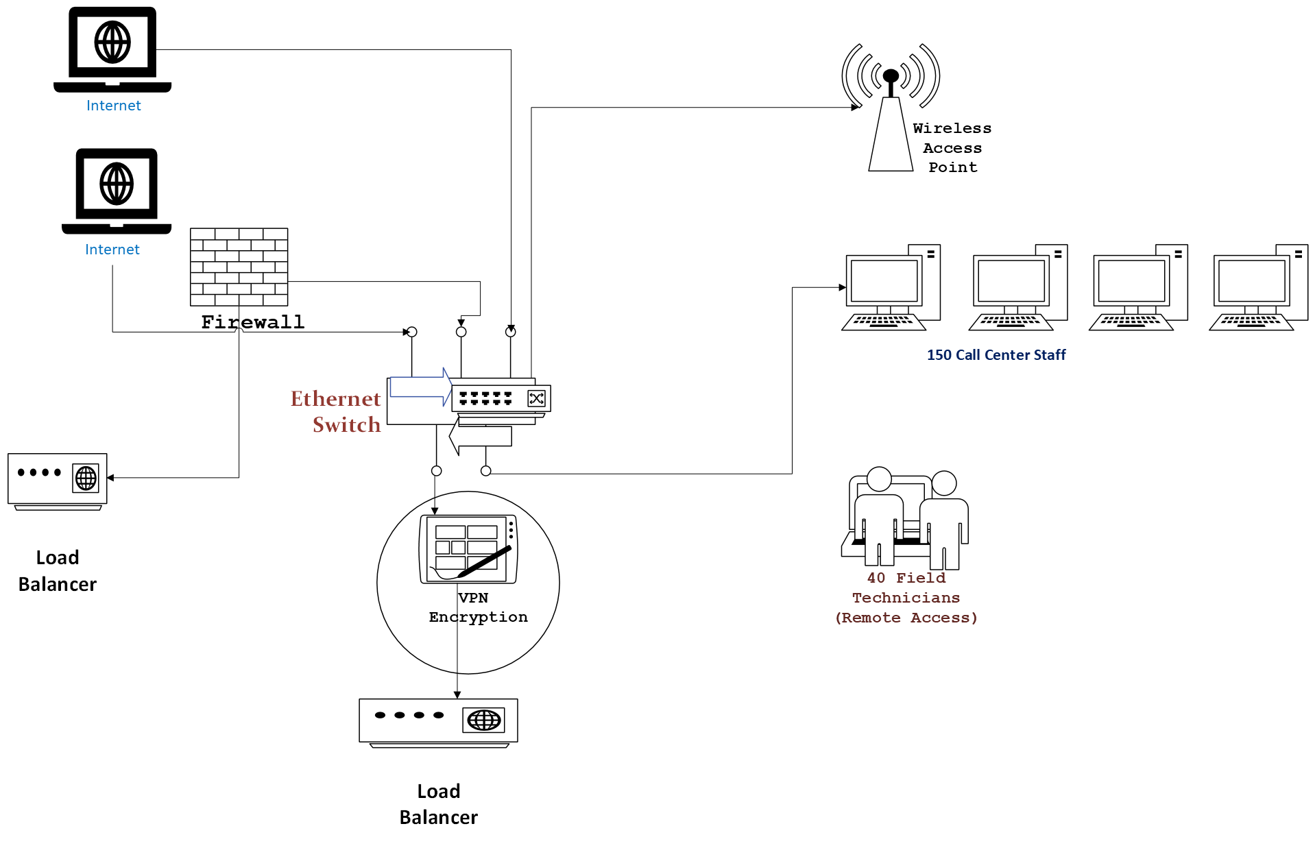
6.2 Remote Access Infrastructure
VPN Configuration
- Platform: Palo Alto GlobalProtect
- Portal: vpn.techsupport.com
- Authentication: RADIUS + RSA SecurID
Field Technician Access Notes
VPN Pool: 10.6.0.10-100
Split Tunnel: 4 hours
Max Sessions: 50 concurrent
MFA Required: Yes
Management Access Methods
- SSH: Port 22 ( Management Access Methods)
- HHTPS: Port 443 (Web management)
- SNMP: v3 only (Encrypted)
- Console: Via Opengear console server
- SECURITY MEASURES
7.1 Firewall Configuration
Zone-Based Security Policy
Source Zone | Dest Zone | Application | Action | Logging
OUTSIDE | DMZ | HTTPS/443 | Allow | Yes
DATA | INTERNET | HTTP/HTTPS | Allow | Yes
VOICE | VOICE_GATEWAY | SIP/RTP | Allow | No
FIELD_VPN | SERVERS | RDP/SSH | Allow | Yes
GUEST | INTERNAL | Any | Deny | Yes

Key Firewall Rules
1.Deny all inbound except established
2.Allow VoIP to SIP trunk provider
3.Allow VPN connections (IKEv2/IPSec)
4.Rate-limit DNS queries (1000/sec)
5.Geo-blocking: Allow US/Canada only
7.2 Intrusion Detection/Prevention (IDPS)
System: Palo Alto Threat Prevention
- IPS Profile: Strict (Block critical/high)
- Anti-Malware: Real-Time Scanning enabled
- URL Filtering: 62 categories blocked
- SSL Decryption: Enabled for non-financial sites
- Threat Intel Feeds: Updated every 5 minutes
7.3 Security Protocols and Standards
Network Security Controls
- 802.1 X: Port-based authentication (all switches)
- MAB: Mac authentication bypass for phones
- DHCP Snooping: Enabled on all access VLANs
- Dynamic ARP Inspection: Prevents ARP poisoning
- Port Security: Max 3 MACs per port
- Storm Control: Broadcast 1% Multicast 2%
Compliance Requirements
- PCI DSS: Call center payment processing
- HIPAA: Healthcare client data
- SOC 2 Type 2: Annual Audit

COST CONSIDERATION
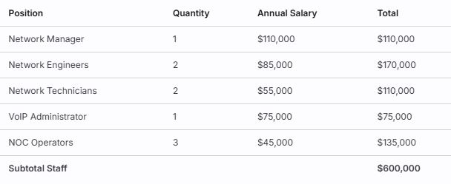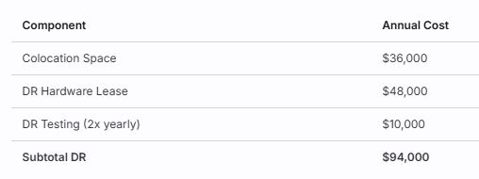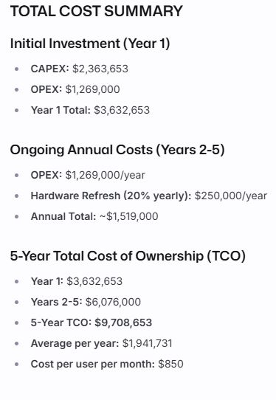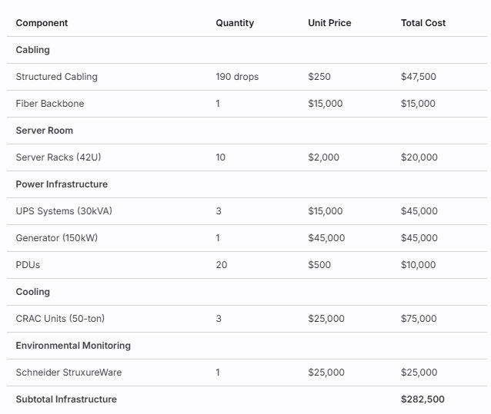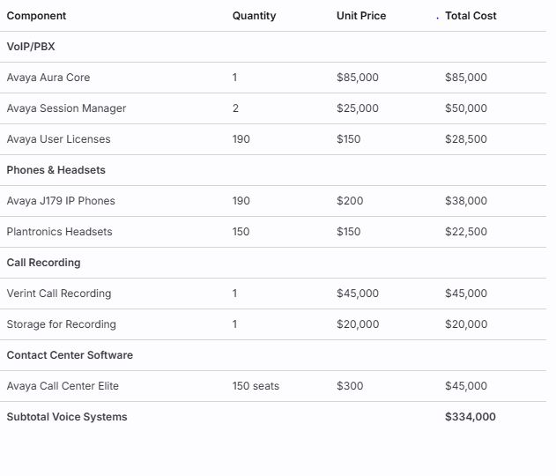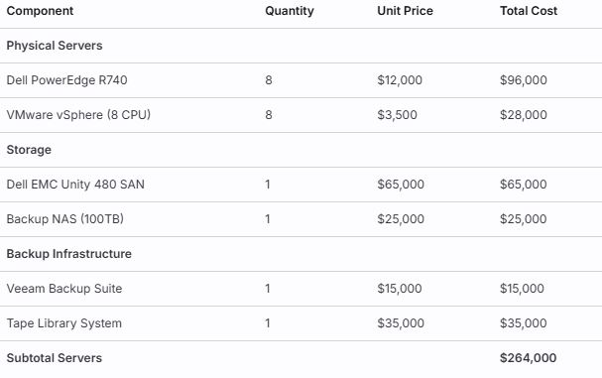 (Products | Fortinet Products | Fortinet Product Information, n.d.)

Approved By:__________________
Date:______________________
NEI Approved By: DeShaun Riddick______
Date:_____12-15-2025___________

References:
5 steps in the change management process | HBS Online. (2020, March 19). Business Insights Blog. https://online.hbs.edu/blog/post/change-management-process

Aleksic, M. (2025, April 10). What is a cross connect? {Data center tech explained}. Knowledge Base by phoenixNAP. https://phoenixnap.com/kb/cross-connect
An In-Depth Guide to writing network Documentation | NetBox Labs. (n.d.). https://netboxlabs.com/blog/an-in-depth-guide-to-writing-network-documentation/

Andrea, H. (n.d.). Cisco Router HSRP Configuration - two examples. Networks Training. https://www.networkstraining.com/cisco-router-hsrp-configuration/

Chube, P. (2011, October 14). CRAC unit sizing: Dos and don’ts. ComputerWeekly.com. https://www.computerweekly.com/tip/CRAC-unit-sizing-Dos-and-donts

Cisco Nexus 5000 Series Switch CLI Software Configuration Guide. (184444). In Cisco Nexus 5000 Series Switch CLI Software Configuration Guide [Book]. https://www.cisco.com/c/en/us/td/docs/switches/datacenter/nexus5000/sw/configuration/guide/cli/CLIConfigurationGuide/RPVSpanningTree.pdf

Cisco Nexus 9000 Series NX-OS Release Notes, Release 9.3(8). (2024, April 25). Cisco. https://www.cisco.com/c/en/us/td/docs/switches/datacenter/nexus9000/sw/93x/release/notes/cisco-nexus-9000-nxos-release-notes-938.html

Comment, L. K. J. 1. 2. 0. (n.d.). Top 10 Network Dashboard Templates with Examples and Samples. https://www.slideteam.net/blog/top-10-network-dashboard-templates-with-examples-and-samples

CPS Geographic Redundancy Guide, release 24.2.0 - GR Reference Models [Cisco Policy Suite for Mobile]. (2024, September 13). Cisco. https://www.cisco.com/c/en/us/td/docs/wireless/quantum-policy-suite/R24-2-0/CPS-GeographicRedunduncyGuide/cps24-2-0geographicredundancyguide/m_grreferencemodels.html

GeeksforGeeks. (2025, July 23). Hierarchical network design. GeeksforGeeks. https://www.geeksforgeeks.org/computer-networks/hierarchical-network-design/

Infoblox. (2025, November 5). InfoBlox - Future-Proof DDI to unite networking and security. https://www.infoblox.com/

J, H. (2025, February 11). 7 Best Network Inventory Tools for 2025 - with Free Trials! Network Admin Tools. https://www.netadmintools.com/best-network-inventory-tools/
Kirvan, P., Gillis, A. S., & Fontecchio, M. (2025, June 12). What is PUE (power usage effectiveness)? Search Data Center.
https://www.techtarget.com/searchdatacenter/definition/power-usage-effectiveness-PUE

PAN-OS 10.2.4 known issues. (n.d.). https://docs.paloaltonetworks.com/pan-os/10-2/pan-os-release-notes/pan-os-10-2-4-known-and-addressed-issues/pan-os-10-2-4-known-issues

Products | Fortinet Products | Fortinet Product Information. (n.d.). Fortinet. https://www.fortinet.com/products

Shibboleth Authentication Request. (n.d.). https://www.proquest.com/docview/2893140748?parentSessionId=Jmp4uyv0gemBpckxkMsoOeGX8BfFKWE64LsgE8BthEs%3D&pq-origsite=summon&accountid=44759&sourcetype=Scholarly%20Journals

